Jeroen P. Broks


Neil Programming Language
Starter's Guide
Table of Contents
Introduction to this guide 3
1. History of Neil 4
2. “Hello World” the traditional first program 5
3. An introduction to variables 8
3.1 A simple program using variables 8
3.2 Changing variables as the program goes 9
3.3 Using variables in mathematics 12
4. Functions 14
4.1 Introduction 14
4.2 Simple “void” functions 14
4.3 Functions that do return a value 16
4.4 Static local variables in functions 17
5. If-statements and looping 18
5.1 The “if” statement. 18
5.2 The WHILE loop 21
5.3 The REPEAT loop 22

Introduction to this guide
In this guide I will explain to you how to use the Neil Programming Language.
Neil is a transcompiling language, which means that it doesn't compile to machine language, but to a different language and in the case of Neil that's Lua, and therefore Neil can be used with any Lua based environment (requires Lua 5.1 but 5.2 or later is recommended, as some features Neil offers are not supported by 5.1). In the “History” chapter I will go into the deep why I created this language.
Now in this guide I will assume you never ever coded before, and that is why this guide will take things from the basics. Most of the example programs, and programs I will make you write yourself (because “The only way to learn a new programming language is by writing programs in it”, wise words by Dennis Ritchie, creator of the C programming language) are based on the program QuickNeil. QuickNeil is a program written in C#, and therefore it does require .NET to be installed, not really meant for serious projects, but it's ideal for prototyping with Neil and trying things out. You can find QuickNeil in my github repository here: https://github.com/NeilProject/QuickNeil – I recommend you not to download the source and compile it yourself, but to go to the “releases” tab where you can find a pre-compiled version of the program so you can start immediately.

Basically I will explain how a few things work and give you a few tasks to try things out for yourself with Neil. You will quite often find a few special paragraphs in this guide and I will explain what they mean here.

Whenever you see text written in an amber colored block like this in combination with the smiley you see to the left of here, it means that the text written in this block can be considered “nerdy”. These blocks have most of all been added for those who are already well-versed in coding in general and may wonder about a few related aspects. If you are new to coding, you can best skip these boxes and they may if you are not yet quite knowledgeable and trained in coding, the content of these blocks may confuse you.


Now when you see stuff in a cyan background accompanied with the flask icon, it means I am actually to write an actual program in Neil yourself. After all you learn this best by actually doing it. As I said before, it's actually the only way to do it.
Now it also pays off to try out some things you think off yourself, and if you get it to work, you may progress even more. Coding is a matter of trying out, no matter which language you use and Neil is not an exception.

And last but not least, these darkblue parts with this particular font are “code blocks” which I'll use to give you some example code.

Well, with all this explained I think we are ready to start this all up.

1. History of Neil
Like many people my age who are programmers/coders now I came in touch with home computers in the 1980s where the BASIC programming language served as a kind of OS. Working with BASIC did show me I had a talent for this. When I was a teen I switched to Turbo Pascal by advice of my back then mathematics teacher and this was the beginning of developing my skills as a coder.
When I got later into Windows I had to switch a lot between languages. Eventually when my interest focused most of all on RPG games, using scripting languages became an absolute need. Since my core language BlitzMax provided me with Lua, it was an obvious choice.
Now what I personally never liked about Lua, most of all in the bigger projects is that it has no variable declaration need, and this can lead to a lot of nightmares when code typos pop up along the ride. I also never like the case sensitivity and getting yourself into OOP with Lua, well officially it's not supported, but there are dirty ways to do it anyway. Out of a bit of frustration about this I originally invented NIL, which stands for “NIL Isn't Lua”. NIL is just a Lua script translating to Lua. I later decided to make Neil as a better language, and so it all came to be.
The name Neil is not related to NIL (which was also a pun on the most hated word in Lua “nil”), but coincidence wanted its name comes close to the name of the first man on the moon, after which Neil was named, this because Lua means “moon” in Portuguese, and yes that was intentional, since Lua has been designed in Rio-de-Geneiro, in Brazil, and yeah, Portuguese is the main language there. The first big usage of Neil was in the game engine that was named Apollo, which is named after the mission to the moon, yes....

Now I may write a guide about Apollo later, as Apollo requires a bit of more mastery of Neil, and Neil can basically be used in any Lua based engine, so in this guide I will focus on Neil itself most of all.

2. “Hello World” the traditional first program
Traditions should be upheld... or so they say. The first program should always be “Hello World”. Well this program is just perfect to get things on the run anyway, and long the ride I can tell you also a bit of how to use QuickNeil.

“Hello World” is accredited to Ken Thompson, who worked with Dennis Ritchie in the development of Unix, and also played a big role in the invention of the C programming language. “Hello World” was used to demonstrate the language when it was still in a very premature state. Due to its simplicity, since all it does it put “Hello World!” onto the screen, it has ever since been used to test and demonstrate programming languages, and it has also become a program used to give people their first programming lessons.

Now before I begin on how to write “Hello World” in Neil, I first want you to download QuickNeil and to put the contents of the zip file into your work folder. Now I prefer PowerShell myself in Windows, but cmd should also work. When you are on Unix based systems or Linux you will need either Wine or Mono in order to run QuickNeil, which basically works when you write “wine QuickNeil.exe” or “Mono QuickNeil.exe” in stead of just “QuickNeil” as you would in Windows.

Run QuickNeil in your CLI environment and you should see something like this:
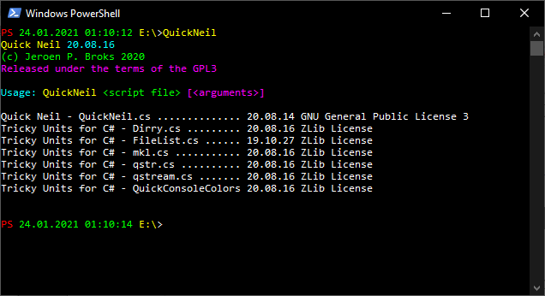
That should mean QuickNeil works, or well, it should.
Now we can use our favorite PLAIN TEXT editor in order to write our programs. I used jEdit myself (because I could most easily set up a quick syntax highlighter in it), but most plain text editors will do, except Notepad (Windows) or TextEdit (Mac)... TextEdit in particular is a very big No-No and will likely not make anything work at all.

Well let's get this to move then, shall we?
Init
Print(”Hello World”)
End
Well, that's all, just create a file containing this code (please note that I used an office suit which does replace the double quote character with a non-ASCII variant the Neil compiler does NOT understand, so best it NOT to copy code directly from this guide into your programs) and just call it “HelloWorld.neil”
Now if you type “QuickNeil HelloWorld.neil” this should happen
Hello World

Now what is actually happening?
The word “Init” is a keyword in Neil. Keywords are reserved words that may not be used for other purposes as for what the language has set them up for. Now Neil is a procedurial scripting language, and that means it normally means it only provides functions that the underlying program calls and works things out from there, however sometimes stuff needs to be done before all that happens. “Init” is a kind of a block of code normally meant to do this stuff, and it is always executed just after the code has been translated. Perhaps this is not the right moment to digest this info. As far as QuickNeil is concerned, Init will start stuff... For now that's all you need to really know, but I had to tell the rest as otherwise I would make false statements.

The keyword “End” ends portions of code. We call these “scopes”. “Init” began the scope and “End” let's Neil know it ended. Print is the actual instruction to put the words “Hello World” onto the screen.

Now normally when a scope, in this case “Init” starts all code that comes next until “End” is executed in the same order in which it is written. And there is no official limit to how many instructions you give. In Neil it is however recommendable to start each instruction on a new line (mostly even required).

Now let's take a look at this program:
Init
print("Hello, my name is Jeroen P. Broks")
print("I was born in 1975 in the Netherlands")
print("Pleased to meet you")
End
You can find this code in the samples folder as “IntroJeroen.neil”

I think its output should be obvious:
Hello, my name is Jeroen P. Broks
I was born in 1975 in the Netherlands
Pleased to meet you

Right, and now to get to work yourself. With the stuff I just explained you should be able now to use QuickNeil to write a program that displays your name, street address and hometown (don't worry, there's no secret spyware built into QuickNeil).

As an extra practice perhaps you can also write a program that displays the names of some animals you like.

3. An introduction to variables
Variables are one of the most important things you'll get to work with in many many programming languages, including Neil.
Now for people who never programmed before the question arises, what a variable is. Well, it is kind of a “container” for data. Neil can assign data to it, manipulate it and read it. Well I guess it couldn't get more abstract than that, eh?

Now Neil basically has multiple kinds of variables. The global variable, which is accessible throughout your entire program. You are advised to use them as little as possible (if possible not at all). Local variables, which only live in the scope in which they have been “declared” (more about that later), and then you have field variables and properties, but the those two will not be discussed in this chapter at all, as they come into play when we get to classes and groups.

Now every variable can have several types. For now I'll limit myself to the most common ones. “int” and “string”, but there are more types Neil supports. “int” variables can only hold numbers and then only integer numbers, so 1,2,3,4 etc.... Numbers like 4.3 or 3.14 and so on are not supported by “int”. “String” variables are used to store text in... well not entirely correct, but that is what it comes down to.
I'll try to break stuff down in sections when it comes to variables.

3.1 A simple program using variables
string name="Jeroen"
int yob=1975

Init
cout("My name is ",name," and I was born in ",yob,"\n")
end

Now let's see what is actually happening here. In Neil variables need to be declared. This will make Neil know a variable exists, but also what kind of data it should hold. The first two lines are used for this. The first line tells Neil to create a string variable called “name” and to assign the text “Jeroen” into it. The second line tells Neil to create a variable called “yob” and to store the number 1975 into it.

These two variables are accessible over the entire file, that is in this case the entire program, but when you get more advanced in Neil you will eventually use multiple files for a program or script and then these variables only live this file. For that matter they are “local”. We can make them even more local, by doing this:

Init
string name="Jeroen"
int yob=1975
cout("My name is ",name," and I was born in ",yob,"\n")
end

Now they are only accessible within the “Init” scope. Right now the only scope we have, but soon you will work with multiple scopes (most of all functions) and then this can be even more important.

Now I used “cout” in this example. “cout” simply means “console output”. I prefer that when working with variables like these as the output works out more elegant. If you wonder about \n, that is just a quick way to start a new line, as unlike “print” “cout” doesn't do that.
If you wanna know why I prefer “cout” try this and you'll see soon enough:
Init
string name="Jeroen"
int yob=1975
print("My name is ",name," and I was born in ",yob)
end

Now I must make note of it Neil is case insensitive. It doesn't care about upper or lower case. So “Name” and “name” and “NaMe” are all seen as the same variable. People who have a lot of experience with case sensitive languages (like C, C++, Lua, Java, C# and many more) should really keep that in mind.

The output is of course “My name is Jeroen and I was born in 1975”. Given the values I gave to the variables that is only obvious. Change these variables and the output would adapt.

Create a simple program that stores your name and age in variables and make it output this data in the format “Hi, my name is nnnnn and I am aaaa years old”

You may try to change the numbers every now and then to see what will change.

3.2 Changing variables as the program goes
Now it's cool we can put stuff into variables, and even than we can read them. But what good does that do? Can't we change variables as we go?
Well, as the name “VARIABLE” already implies you can. There are several ways you can do that. The easiest way to go is by replacing the variable's value completely.
Init
string animal = "dog"
string sound = "woof"
cout("A ",animal," says ",sound)
animal = "cat"
sound = "meow"
cout("A ",animal," says ",sound)
End
The first thing you may see that in the second definitions I didn't use the keyword “string” anymore. This is because it's not needed, the variable is already declared before and Neil knows it's a string. In fact using that keyword again will confuse Neil, making it think you are declaring a new variable with a name it already has, which will lead to Neil giving an error message.
So, what I basically did was just putting in new values into the variables I already had, and as a result different outcomes appear when the cout instruction, which is in both cases the same, is executed.

However there are more things you can do. You don't always have to replace a value completely. You can also manipulate the value, like demonstrated below:
Init
int a = 5
print(a)
a++
print(a)
a--
print(a)
a+=5
print(a)
End
The output will be the numbers 5, 6, 5 and 10 under each other.
Can you see what actually happened?

“++” is called an “incrementor”. When used on numberic variables, and since “a” is an integer this is the case it will increase its value by 1. “--” is the “decrementor” and will decrease the value by 1. So this explains the first three numbers.

Perhaps you already understood what “a+=5” did. Yes, it increased the number inside “a” with 5. Since the value of “a” was 5 at the time it would as a result become 10.
What is important to note for those who are well-skilled in C and C++ is that the support for these features is in Neil not nearly as sophisticated as in C and C++. A line line “print(a++)” is NOT gonna work in Neil, so don't even try it.

In the example above I did use the number 5 for increasing, but in stead of a “constant value” as 5 is called in this case, we can also use a variable. Let's expand this little program a littlebit, shall we?
Init
int a = 5
int b = 10
print(a)
a++
print(a)
a--
print(a)
a+=5
print(a)
a+=b
print(a)
End
Since 'b' now contains value 10, it's only obvious now that a, which contains 10 at the point the last addition is done, increased by 10, will as a result contain the number 20.

Write a small program which contains an integer variable named “a”, and make it contain value 1. Then make it increment by 1 five times, and make it then five times add its own value to it.
Between every line that alters the value of a must be a “print(a)” showing what th result is.

Now lastly before I move on, it is nice to note that “+=” also works with strings.
Init
string N = "Jeroen"
print(N)
// MIND THE SPACE BEFORE MY NAME!!!
N += " Jeroen"
print(N)
End
Now “//” is in Neil used to add comments to code. Neil will ignore comments, but they can help you to make your code more readable.

Now the output will be “Jeroen” on the first line and “Jeroen Jeroen” on the second. As you can see Neil can therefore add extra text to a string by using “+=”

3.3 Using variables in mathematics
Now we come to the point that you do need to understand the fundamentals of mathematics. Of course, there are some misconceptions about the need of mathematics in coding. When it comes to being able to calculate things yourself, with or without the use of a notepad, then I say, no, then you don't really need it. I am horrible in that myself and yet I could set up my own programming language, come on. What you need to understand is the mechanics behind mathematics, the way formulas work.
When it comes to coding mathematical formulas are downright legio. The previous section already showed a bit of that, but now we are going into a bit more serious work.

INIT
print(4+6)
END
Let's start simple. The code above will make QuickNeil put “10” onto the screen. This of course because 4+6=10.
Question is if it can do more complicated calculations like that? Sure:
INIT
print( (4+6)* 3)
END
This will show 30. As the rules of mathematics go, you must first do 4+6 as it's between ( and ), and then multiply the result with 3, and as 4+6 is 10 it will become 30 when you multiply this with 3.

The “operators” Neil uses are + (add), - (subtract), * (multiply), / (divide), “div” (integer divide), and % (modulo). For those to whom the word “modulo” doesn't make sense, that is the “rest value” of a divide. 10%3=1 as 10:3=3 rest 1.
The difference between / and the keyword “div” is that “div” will always produce an integer regardless if the outcome of a division actually is an integer. The instruction “print(5/3)” would output “1.6666666666667”, where “print(5 div 3) would output “1” and ignore all decimals (as you can see it does NOT round). Important about “div” is that it requires Lua 5.2, as Neil uses a feature for that which was not present in Lua 5.1
I already hear people who are well versed in pure Lua ask why I used the keyword “div” for this and not Lua's default operator “//”. Well folks, that's easy. As Neil uses “//” for comments already this was not possible, and since comments are far more common with “//” I decided to stick onto that. The keyword “div” was copied from the Pascal language, where the keyword serves exactly the same purpose, and is also used in exactly the same manner. Of course, it's easy to guess that Neil translates “div” to “//” in pure Lua code, and since that operator was only introduced in Lua 5.2 you now know why that version or later is required for this.

Now we're going to make this a bit more interesting. Up until now we've only been discussing pure numbers, but yes, variables can be used for this too. If you know how to use variables in normal mathematics, well, in coding it's not so far of. Only vital difference is that in pure mathematics “ab” means “a x b” where in coding it's just one variable. Well, maybe that's not entirely correct, but in order not to make things too complicated, we'll keep that as the rule for now.
INIT
int a = 5
int b = 7
print(a+b)
int c = b - a
print(c)
END
Well, that looks simple enough, eh? Well, yeah, the fundamentals are this simple, really. And yes, the result can be directly sent to a function call (which “print” is, I will get into the deep of functions soon), but it can also be done in a variable definition.

Now for this assignment I will assume everybody is having birthday at January 1st, as this could otherwise be too complicated for the level we are now on.

Now the task is easy. Create a program with three variables. One holding the year we are in right now. The second variable should hold the the year in which you were born. And the third should contain the number of years old you are now by calculating it from the other two variables.

Of course when it comes to strings we all know that you cannot apply mathematics to them, but that doesn't mean that there are no formula's at all possible. Now there are a lot of functions with strings in Neil and the underlying Lua scripting engine, however there is one operator for strings that is a kind of mathematic. And that is the “..” operator. It can be used to merge to strings together. We call this “concating” or “concatenation”, although I must say it's been a very long while ago since I used that term last.

In a basic sense the “+=” instruction I mentioned earlier is already performing concatenation. Neil can do it also like this:
Init
print(“Jeroen”..” ”..”Broks”)
end
Or this:
Init
string first = “Jeroen”
string space = “ “
string last = “Broks”
string complete = first .. space .. last
print(complete)
end

String concatenation is something you may use a lot in Neil programs.

4. Functions

4.1 Introduction
Functions are one of the most important things you will have to understand. In order not to turn your program into one gigantic mess they are absolutely essential. Not to mention that they prevent you from having the same the same instruction thousands of times over and over (and if you do it wrong prevent your from making all the same fixes over and over).
Functions are a kind of “mini-programs”. When called the code they contain will be executed, and when their task is fulfilled the main program will resume where they were on the moment the function was called.
So far “print” and “cout” are the only functions we've used so far, and they have been predefined by Neil. There are many predefined functions in Neil, however Neil also allows you to create your own.
Now just like variables functions can have types like “int” and “string” and well, any type a variable can have. Functions are able to “return values” which the main program can use, and how that works is something I will explain later. For functions there is also the “void” type, meaning no value will be returned. Since “void” functions are the easiest to understand I will start with these first.

4.2 Simple “void” functions
Now in order to create a “void” function we got the keyword “void”. Let's create a quick program which should make clear how a void function is created and called.
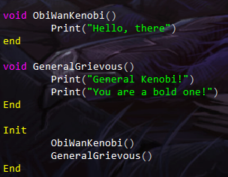
As you can see “void” began the function definition, and just like “Init” the content of the function. The () are an important part of the definition. This is how Neil knows you are declaring and defining a function and not a variable. Seems pretty obsolete for “void” functions, but when we get into functions returning values, you may understand. () has also another function but that comes later.
The output shows how functions work. First the function “ObiWanKenobi” is called and I told Neil there to put “Hello, there” onto the screen. Of course the other function shows the famous reply General Grievous gave in “Star Wars – Attack of the Clones” which has become a kind of a meme (hence me using that in this example).
Now it goes without saying, but yes, if you put “ObiWanKenobi()” five times in a row in your code Neil will respond with putting five times “Hello, there” onto the screen. It's obvious now how functions can save you loads of time and tons of lines of needless code. Many computer programs, no matter in which language they have been written contain countless portions of code that has to be executed again and again and again.
Create five functions in a program and name them after animals and let them show the sound these animals make onto the screen. The functions themselves should only do this once. Now in the Init-block call all functions once, but put of them in your code multiple times on any position you like, and see what happens.

The next step in functions is the function parameter, or arguments. These are defined between the (). Since the functions in the example before didn't need parameters we just wrote (),but now we're gonna use the space between them.
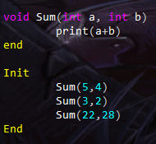
As you can see the parameters is defined in a similar way as normal variables and in fact, once the function runs even handled in the same manner. Of course “a” and “b” are local variables bound to the “Sum” function and are therefore inaccessible outside this function. So if you try to call for them in the “init” block Neil will just throw an error.

The working is easy. Sum(5,4) → call Sum with 5 as first argument and 4 as the second → first argument variable is a so assign the first value to it, which is 5, and b is the second variable so assign the second value to is so that is 4 → So that means a=5 and b=4 → print(a+b) is therefore print(5+4) → The outcome is 9, so that has been put onto the screen → End is reached so we go back to the Init block and execute the next instruction there which is Sum(3, 2), well and so on.

Yes “string” can be used here too, and basically any other type I did not yet discuss can be used.

Now the Sum function has become more functional than my Star Wars functions before. After all any integer number can be used now.

Right, let's make this assignment a bit more complex than the earlier ones, and in the assignments folder you can find my version of the code that should come out with this.

Take a note of this famous poem:
10 green bottles hanging on the wall,
10 green bottles hanging on the wall,
And if one green bottle should accidentally fall,
There'll be 9 green bottles hanging on the wall.
Well, let's make this count down. So write a function that recites the poem and will also make note that there's at the end one less. The number of bottles you initially have should be the functions argument, and the function must therefore the one bottle less print calculated by itself.
Of course, then call the function ten times and with the first time 10 as parameter and in the last one 1. Now for the grammar nazis among us, in order not to make this too hard, we'll ignore single and plural form, so “1 bottles” will for this assignment be seen as “grammatically correct”. (Really awful I need to note that, but yes, people are this pathetic).

4.3 Functions that do return a value
Now we get into another thing functions can do. Returning a value. I could talk a lot about this, but perhaps it's better to show you.
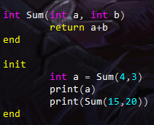
Now this looks a bit freaky, doesn't it? Well the entire code makes perfect sense. With “int” we tell Neil we want the “int” type for Sum, and since we used () here Neil knows this is not a variable, but a function. The arguments work the same as in void functions.
What is new now is the “return” keyword. It terminates the function execution immediately (so any commands coming after it will be ignored, and Lua will even throw an error in this particular example) and will return the value requested. In this case the outcome of “a+b”, whatever their values are.
Now if we look at the “init” block you can see that the function call can be used the same way as we read out variables, and that means it can be used to define a variable with the outcome, and also as a parameter for another function.

Try to play a bit with this. Create a function that returns the value given to it as an argument multiplied by 2. And assign the doubled value to a variable (give any number you like as argument)
The add a line that puts the value of that variable on screen.

4.4 Static local variables in functions
Up until now we've only be using local variables that live inside a function and which basically reset whenever a function is called again (well, not entirely true as there's also recursive function calling, but that is not important now), static local variables only live inside the function so they are not accessible outside that function, but their value will not be reset.
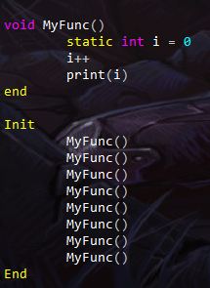
Now in order to do this you just need the keyword “static”. If you run the program you'll see 1,2,3,4,5,6,7,8 under each other. Now if you remove the keyword “static” you will just see 8 times the number 1 appear.
This is because without the word “static” the variable “i” is declared and defined with the number 0 every time the function is called, and thus 8 times the number 1 is then only a natural outcome. Now thanks to the keyword “static” the variable “i” remains local and can thus only be called inside the scope in which it is declared, in this case the “MyFunc” function, but the value 0 is only assigned to it on the moment the the function is called for the first time. On later calls the line will be ignored and the value “i” had at the end of the previous call will just be used, and hence the counting up.

Now I will not give any assignments on this one, but I just told you as I think it's nice to know the feature exists, and aside from C and C++, Neil is the only language I know this is supported, so use it to your advantage.

5. If-statements and looping
In this chapter we are now really going to make programming interesting. For example in a game, a game keeps going, but when an enemy touches you, your hero dies. Well, the “if” statement can be used to check if the enemy and player touch each other and to perform certain actions if so.
Looping is to make a program, or portions of it repeat over and over.
The “if” statement doesn't loop, but I included it in this chapter because the way if checks stuff is not much unlike how loop routines do that. When it comes to looping, Neil has basically three types of loops. The while-loop, the repeat-loop and the for-loop. Now strictly speaking there is also the “for-each-loop”, but I will handle that in a different chapter.

5.1 The “if” statement.
Whenever the keyword “if” is encountered, which must always be at the start of an instruction, Neil starts a new scope. Behind the “if” command an expression must be given. Is the outcome true then the scope that comes next will be executed. Is the outcome false, it will be skipped. Well, it's basically that simple.
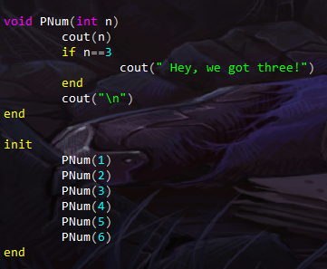
And this is the output:
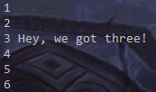
Of course, that Pnum is simply a function called with 6 different values by init is all clear, and as you can see when the number is 3 you can see an extra reaction, which doesn't happen for the other numbers. So “if” does its magic here.
The “n==3” expression is called a “Boolean” expression. It was named after George Boole. An English mathematician. Boolean expressions have basically always either one of the two outcomes “true” or “false”. These are actually values. But I'll come back to that later.
Now mind the fact that you need to type “==” and not “=”. This has been done to make sure no confusion can arise between checking two values and defining values. There are more boolean operators out there, and I will get into them soon.
Let's first test if you've been paying attention to this and to earlier chapters and sections.

The program above is of course pretty bogus. You should be able to do better by now.
Can you make a program in which there's a function not taking arguments, in which a number is incremented and in which the system says “boo” if that number is 3 and “pfew” if the number is 6. The number itself must be imprinted first and the “boo” and the “pfew” should come after it. The program should now count till 10.

(You can find my code how I solved this assignment in the Assignment folder).
Now for value checking there are basically these operators:
== equals to
!= does NOT equal to
< is lower than
> is greater than
<= is lower than or equals to
>= is greater than or equals to
I could show you example code, but why don't you try something yourself. Perhaps you can now write a program similar to that of the previous assignment which says “is not 3” when a value is not three.

And then another program in which the program mentions if a number is lower, equal to or greater than 5.

Lastly we're going to make things a bit more interesting. Neil also features the operator “||” (for which you can also use the keyword “or”) and “&&” (for which you can also use the keyword “and”).

Well “||” aka “or” means, either one check or the other must be true (both is allowed), and “&&” means that both conditions must be true.
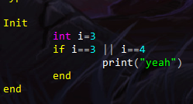
This is a nice code snipped to test “||”... Since “i” contains 3 “yeah” will be put onto the screen. If you now change this code and later “i” and make it 5 it will look like nothing will happen, but when you make it 4 you will see “yeah” again.
If you want to know, is that in order to make performance quicker || stops all checking once true is encountered. After all the next value no longer matters. This is however important to know when you use if with functions and properties as they do some special actions before returning a value which can be checked here, and if you are then not alert to that the program can act in a way you never intended and then we speak of a “bug” (and not of a “glitch”).

Same note should also be made about the && operator. As soon as “false” is encountered, it stops checking, since both values had to be true, and if the first one is false already, whatever comes next no longer matters.

Anything the computer doesn't need to do because it doesn't matter is basically winning performance. Especially since Neil uses an interpreted environment you do not want to do things that are not needed.

Now before moving on to the next section, I told you before that the outcome of the boolean checks, “true” and “false” are actually values, and that means you can assign them to a variable. Neil uses the “bool” type for that. You can either just assign “true” or “false” to them, but you can also assign the expression itself to them, and the variable will then contain “true” or “false” based on the outcome.
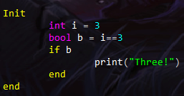
Now this is a bit of a “clunky” approach for something very trivial, yet this will be useful in more complex code, especially since you can also return this as a function value.

For the next part of this lesson, we'll go a bit in the deep of “if”. You can also say if something is the case do this or else do that.
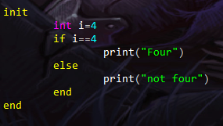
Well, yeah, it's that easy. If you run the program now it will say “Four” and if you assign any other value to “i” the output will be “not four”.
Now what you need to know next is the “elseif” keyword. It will when the first “if” is “false” come into play and check the next statement. If false skip the scope that comes next. However if the first “if” is true “elseif” and the entire scope attached to it will be skipped. The number of “elseif” statements you can attach to one “if” is generally endless, but as soon as the first “true” is found, the scope with it will be executed, and all others will be skipped.
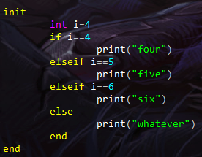
This basically illustrates how “elseif” can be used.
Yes, this looks ugly and yes, there is a more elegant way to do this, as Neil does support switch statements. However this comes later. I was just demonstrating how “elseif” works in Neil.
Now I'll give you one thing before hand. The quickest way to find out if an integer number is dividable by another integer number is by checking if the modulo turns out to be 0. So if x % 7 = 0 it means that x is dividable by 7. After all modulo is the rest value of a division, and when a number is dividable there is no rest value. And yes stuff like 1+1 and a+b can be put into a boolean expression and as such into an “if” statement.

Knowing this do the following. Create a function with an integer parameter which will say “Yo!” if a number is dividable by 3 and say “Bye!” if a number is dividable by 7. Now in this program being dividable by 3 takes priority over 7, so if the number is dividable by 3 and 7 it should say “Yo!”. If the number is dividable by neither it should say “Huh!”

Good luck (You can find the solution in the Assignments folder)

5.2 The WHILE loop
The WHILE loop is a very important tool at your disposal to make programming a bit interesting. Now the WHILE command works pretty similar to how “if” works, with the difference there is no “else” this time. The difference with “if” however is that “if” only executes the scope attached to it once, and will after that just move on. A scope created with the WHILE command will keep repeating itself as long as the boolean expression WHILE receives happens to be “true”. As soon as “false” is received, WHILE will stop and execute the next command that comes after the end of the WHILE scope, and so continue the flow.
Now WHILE loops are basically very important due to jump instructions being considered very very evil. In fact so evil that Neil doesn't even support them, and I don't even plan to make it so. WHILE loops are not completely without danger though, as when you use them improperly your program can loop forever for all of eternity. This is something you should always be aware of. Infinite loops can be a nasty thing if they are the result of bugs.
Well let's just demonstrate what we can do with WHILE shall we?
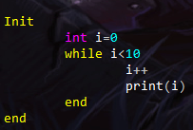
Perhaps you can better try this program for yourself. Copy the code above (it's an image, there's also a file in the “Sample” folder” containing this code), and see what it does.

Yes, you see the numbers 1 till 10 appear under each other on screen. By far more efficient than to write ten times a print command isn't it? The WHILE instruction is where the magic comes from.
“while i<10” basically means “keep repeating as long as variable “i” contains a value lower than 10”. Since and then you will see that the increasing i by 1 is executed and the command that has to put the value on screen, the end of the scope is reached, but as i is still lower than 10, we'll keep repeating.
The loop ends by 10 since as soon as i is 10, it's no longer lower than 10, thus the loop ends.


Now here's the trapdoor. The code above works (I tested it before posting it in this guide, after all), however, let's now pretend that I forgot the line i++. What would happen? Right, not only would the print command then constantly be printing 0, but as i<10 will then always be true, the loop will continue forever. This is what we call an infinite loop. Now infinite loops are not always a problem. As a matter of fact, something they can even be wanted, but when they are not wanted, the consequences could be severe. Now that we are working in a console environment, you can just hit ctrl-c, and QuickNeil will be terminated immediately causing the loop to stop. However when you are working on highly complex games in an engine that doesn't work on the console, the consequences can be very devastating. Depending on the engine even requiring you to completely restart your system. You cannot blame Neil for this. In pure syntax you still got valid code, and Neil and the underlying Lua system cannot know any better than that they are doing what is requested of them.
So yes, use while-loops wherever you can, but always keep in mind to make sure the loop can end somewhere.
And now for your assignment, now make a program that does the opposite of what the program above does. So in stead of counting from 1 till 10, counting backward from 10 to 1. And I mean 1 and not 0. You may however come past a little trapdoor on the way. You should now be skillful enough to see why that happens and what to do to fix that. Solution provided in the “Assignments” folder... no peeking, try it yourself first.

5.3 The REPEAT loop
The “REPEAT” loop is similar to the while-loop with the difference that the boolean checkup is now done at the END of the scope in stead of the start. (Yes, in C we know this as do-while loops). Now Repeat loops are a bit strange as their scope does NOT end with the “end” keyword. In stead you can either use the “loopwhile”, “until” or “forever” keywords.
“loopwhile” means keep repeating as long as the expression is true. “until” means keep looping until the expression is true, and forever will always keep repeating no matter what and thus always produce an infinite loop. “forever” should therefore only be used if you know other ways out of a loop, and I will get to those ways later.

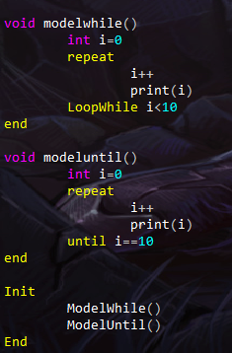
This example demonstrates counting from 1 till 10 with loopwhile and with until. This to demonstrate the two different approaches to use here. Now what keyword is best always depends on the situation at hand.

5.4 The FOR loop
Basically there are two kinds of FOR loops. The general for loop and the for-each-loop. In this section I will limit myself to the normal for-loop as the for-each-loop handles stuff we didn't yet discuss in this guide.

Now the general for loop can be used for quick nummeric counts ups and countdowns. For my 1-10 programs is did use WHILE, but FOR is by far more efficient, but hey I needed demonstrate stuff.
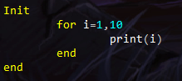
Now this looks a bit odd if you are not versed in programming in general. For declares a local variable in this case “i” and assigns 1 to it, now it will each time the code loops increase “i” by 1. As soon as that would case “i” to be greater than 10, the loop stops. Please note that “i” only works within the for-scope and not outside of it.

Now the example above can increase the variable bound to “for” by one, but you can also make it increase by 2. Like so:
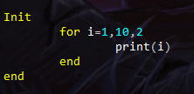
Please note that because “i” began at 1 it will show all the ODD numbers lower than 10. Since 1+2=3. You can therefore also see than now 9 is the last number. Since 9+2 would be 11, the loop stops there, so that only makes sense.

So “for” can be used for anything that is counting up or down.
→ for <workvar> = <startvalue>,<endvalue>,<incrementby (if not given this will be 1)>

Of course, I hear you wonder, can “for” also be used for backward counting? As a matter of fact it can, but then you will have to use a negative value as incrementor value. And then the loop will be constructed in exactly the same manner.
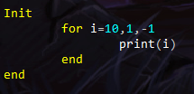
Unfortunately the start value being higher than the ending value is not enough to make the system know the counting is backward, you really must then use -1. Otherwise the loop stops immediately. This is not a bug nor an oversight, it was done on purpose, and in advanced usage of the for-loop you will soon find out why this is.

Now I just used numbers for the for-loop numbers.... Can they also be variables or even mathematical formulas? Sure can be! Watch this:
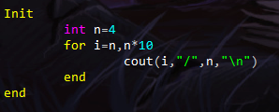
Since n contains the value 4, and n*10 therefore being 40, this program will count from 4 till 40. Should you change 4 with 5, the program will as such count from 5 till 50.

As for your assignment, let's get this combined with stuff you know from earlier in this section.
Make a program that uses a for-loop to count from 1 till 100, however after every number dividable by 5 the program should add an extra whiteline (just type “print()” for that whiteline).

5.5 Breaking off loops prematurely
There are a few ways to break off a loop prematurely. So not at the end of the loop-scope, and also ignoring if a condition for a loop is true or false.

The three ways to do it are the instructions “break”, “return” and “os.exit()”. Now I'll strongly recommend to NEVER use os.exit() as it immediately terminates the entire engine you are using, and if stuff needed to be unloaded first that will all be skipped. All in all not a scenario you wanna be in, so normally that is never an option.

Since “return” terminates the function you are in, it also terminates the loop you in inside that function. This is quite often a drastic measure but sometimes not really out of the ordinairy.
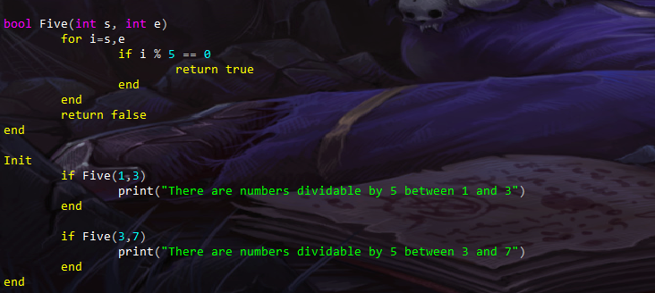
This one for example. It basically checks if in a series of numbers are any numbers dividable by 5. I now just used a for-loop for this and since there is no more need to check the rest once the first number had been found, the loop could be ended, and well, it was easier to end the function altogether and return “true”.

Since “return” also ends the function you are in, it is not always a viable option though. If you only need to break off the loop and nothing else, there's the “break” command.
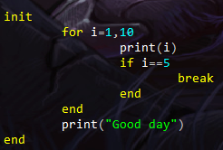
Now this program would normally count till 10, but thanks to my if-line with a break in it, the loop will be immediately terminated when value 5 is reached, and continue at the first command after the loop. In this case the command to put “Good day” onto the screen.

Knowing which break-off to use in what situation is always the trick. For os.exit() it's easy. That's just plain NEVER, but when it comes to “break” or “return” it is just a matter of puzzling things out and also a bit of a matter of experience. Now in the examples above I used the commands in FOR-loops, but they actually work in all loop scopes, including WHILE and REPEAT loops.
Now create a function that takes 1 integer parameters. A start and a ending value. This function must then loop with them and return the first value it encounters dividable by 3. If there 's no value dividable by 3 found, just make it return 0.
Shouldn't not be so hard to do now, right?

